**OCEANA COUNTYJUNIOR MARKET**

**RABBIT RECORD BOOK – 2023**

**(for ages 5-7)**

**AN02757_ AN02757_ AN02757_**

As a member of the Junior Market Animal Project, you are required to submit your records as part of an educational project notebook in order to show your animal at the Oceana County Fair. **This notebook must be shown to the Rabbit Superintendent or designated Small Market Weighmaster at the time of weigh-in and then entered by you in the Educational Notebook Division at the Oceana County Fair on Entry Day.**

**NUMBER OF YEARS IN PROJECT: \_\_\_\_\_\_\_\_\_\_**

**AGE: \_\_\_\_\_\_\_\_\_\_**

Your age you enter depends on how old you were on January 1, 2023.

***Use this sheet as the first page of your project record book. Fill it out completely.***

**Please print or type neatly**.

**Name \_\_\_\_\_\_\_\_\_\_\_\_\_\_\_\_\_\_\_\_\_\_\_\_\_\_\_\_\_\_\_\_\_\_\_\_\_\_\_\_\_\_\_\_\_\_\_\_\_\_\_\_\_\_\_\_\_\_\_\_**

**4-H Club Name \_\_\_\_\_\_\_\_\_\_\_\_\_\_\_\_\_\_\_\_\_\_\_\_\_\_\_\_\_\_\_\_\_\_\_\_\_\_\_\_\_\_\_\_\_\_\_\_\_\_\_**

**Breed, Variety and Age of Doe:**

**\_\_\_\_\_\_\_\_\_\_\_\_\_\_\_\_\_\_\_\_\_\_\_\_\_\_\_\_\_\_\_\_\_\_\_\_\_\_\_\_\_\_\_\_\_\_\_\_\_\_\_\_\_\_\_\_\_\_\_\_\_\_\_\_\_\_**

**Breed Variety Age**

**Breed, Variety and Age of Buck used:**

**\_\_\_\_\_\_\_\_\_\_\_\_\_\_\_\_\_\_\_\_\_\_\_\_\_\_\_\_\_\_\_\_\_\_\_\_\_\_\_\_\_\_\_\_\_\_\_\_\_\_\_\_\_\_\_\_\_\_\_\_\_\_\_\_\_\_**

**Breed Variety Age**

**Do you own the buck? \_\_\_\_ Yes \_\_\_\_\_ No**

**Date of Kindling: \_\_\_\_\_\_\_\_\_\_\_\_\_\_\_\_\_\_\_\_\_\_\_\_\_\_\_\_\_\_\_\_\_\_\_\_\_\_\_\_\_\_\_\_\_\_\_\_**

**No. of live kits: \_\_\_\_\_\_\_\_\_\_\_\_\_\_ No. of non-live kits: \_\_\_\_\_\_\_\_\_\_\_\_\_**

**JUDGE’S SCORE/COMMENT SHEET**

**(PLEASE DO NOT REMOVE, PLACE THIS SHEET IN SHEET PROTECTOR OR GLUE TO COVER). This sheet must be keep free to the judge to write their comments.**

This sheet should help each junior market member understand their ribbon placing.

A. **Specific educational value or worth**

\_\_\_ All questions were answered completely

\_\_\_ All calculations were correct

\_\_\_ Calculations were incorrect

\_\_\_ Questions were not completely answered

\_\_\_ Questions were not answered (missed questions)

B. **Notebook contains all project records**

\_\_\_ Notebook contained all project records and were fully completed

\_\_\_ Notebook contained additional project related information (research

materials etc.)

\_\_\_ Project records were incomplete

\_\_\_There was no additional project related information

C. **Accuracy, neatness and general appearance**

\_\_\_Notebook was neat in appearance (typed/hand printed)

\_\_\_ Notebook pages were clean and stain free

\_\_\_Notebook pages were in order and complete

\_\_\_Notebook pages were out of order and missing pages

\_\_\_Notebook was difficult to read and messy

\_\_\_Notebook had wrinkled and stained pages

Other Comments: \_\_\_\_\_\_\_\_\_\_\_\_\_\_\_\_\_\_\_\_\_\_\_\_\_\_\_\_\_\_\_\_\_\_\_\_\_\_\_\_\_\_\_\_\_\_\_\_\_\_\_\_\_\_\_\_\_\_\_\_

\_\_\_\_\_\_\_\_\_\_\_\_\_\_\_\_\_\_\_\_\_\_\_\_\_\_\_\_\_\_\_\_\_\_\_\_\_\_\_\_\_\_\_\_\_\_\_\_\_\_\_\_\_\_\_\_\_\_\_\_\_\_\_\_\_\_

\_\_\_\_\_\_\_\_\_\_\_\_\_\_\_\_\_\_\_\_\_\_\_\_\_\_\_\_\_\_\_\_\_\_\_\_\_\_\_\_\_\_\_\_\_\_\_\_\_\_\_\_\_\_\_\_\_\_\_\_\_\_\_\_\_\_

2023- JR Market Rabbit Notebook Page 2

## OBJECTIVES

1. Develop desirable work habits, sportsmanship, and ability to cooperate and express ideas through participation in projects, discussions, method demonstrations, judging teams, and exhibits.
2. Experience the pride and responsibility of leasing/owning and caring for rabbits.
3. Learn how to feed, fit, show, breed and raise rabbits.
4. Learn proper handling procedures to prevent injuries to members and their rabbit projects.
5. Appreciate and use scientific information in rabbit production and marketing.
6. Improve knowledge of grading, marketing and merchandising of rabbits and rabbit products.
7. Improve knowledge of the nutritive value of rabbit meat.
8. Learn the importance of the rabbit industry to the local, state, and national economies.
9. Acquire information on the opportunity that rabbits offer as a career.

This record book is part of your Junior Market Rabbit project. By keeping records up-to-date you will be able to see how much progress you make as you set goals and work to accomplish them. Write or type neatly and clearly. Please keep the pages in order. Feel free to add extra pages at the end of your notebook.

SCORING CRITERIA

The following breakdown will be used during the judging process of all market livestock notebooks.

A. Specific educational value or worth **30%**

B. Creative way of showing what has been learned **10%**

C. Notebooks contains all project records **50%**

D. Accuracy, neatness and general appearance **10%**

The Oceana County Oceana Agricultural Society encourages Leader and parent assistance with your project and project notebook.

**If a parent or leader** helped you in filling out your notebook please have them sign below that the answers are YOUR answers and that they assisted you in writing of the answers and understanding of the questions only.

\_\_\_\_\_\_\_\_\_\_\_\_\_\_\_\_\_\_\_\_\_\_\_\_\_\_\_\_\_\_\_\_\_\_\_\_\_\_\_\_\_\_\_\_\_\_\_\_\_\_\_\_\_\_\_\_\_

(Signature of person helping with notebook)

\_\_\_\_\_\_\_\_\_\_\_\_\_\_\_\_\_\_\_\_\_\_\_\_\_\_\_\_\_\_\_\_\_\_\_\_\_\_\_\_\_\_\_\_\_\_\_\_\_\_\_\_\_\_\_\_\_

(Printed name by member)

2023- JR Mkt Rabbit Notebook Page 3

**ABOUT YOUR RABBITS**

***My Rabbits Names are***: (if you did not name your market rabbits, what is the name of your showmanship rabbit)

\_\_\_\_\_\_\_\_\_\_\_\_\_\_\_\_\_\_\_\_\_\_\_\_\_\_\_\_\_\_\_\_\_\_\_\_\_\_\_\_\_\_\_\_\_\_\_\_\_\_\_\_\_\_\_\_\_\_\_\_\_\_\_\_\_\_

***My Rabbits breeds are***: \_\_\_\_\_\_\_\_\_\_\_\_\_\_\_\_\_\_\_\_\_\_\_\_\_\_\_\_\_\_\_\_\_\_\_\_\_\_\_\_\_\_

***My Rabbits favorite thing to do is***: \_\_\_\_\_\_\_\_\_\_\_\_\_\_\_\_\_\_\_\_\_\_\_\_\_\_\_\_\_\_\_\_\_

\_\_\_\_\_\_\_\_\_\_\_\_\_\_\_\_\_\_\_\_\_\_\_\_\_\_\_\_\_\_\_\_\_\_\_\_\_\_\_\_\_\_\_\_\_\_\_\_\_\_\_\_\_\_\_\_\_\_\_\_\_\_\_\_\_\_

**MARKETING**

One of the most important parts of any market animal project is marketing. This may include writing letters and talking to prospective buyers. Color in the face, a smiling face is a good action; a frowning face is a bad action. (see the example)

**Good Marketing Practice Poor Marketing Practice**

****

****

****

****

****

****

****

****

Send a picture to your potential buyers

Send reminders to attend the auction

Go with an adult to speak with your potential buyers and try to answer their questions

Know what kind of feed you use if asked

Only go to the grocery stores or the bank

Only thank those who agree to be listed as a potential buyer

****

****

****

****

****

****

****

**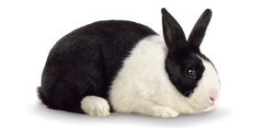**

2023- JR Mkt Rabbit Notebook Page 4

**ANIMAL CARE AND MANAGEMENT**

Your project requires regular care and management. List the things necessary to take care of your project animal(s).

Include the following:

* Feeding and watering practices
* Grooming (clipping, toenail trimming, etc.)
* Health practices and medicines
* General Management (cleaning cages/living area, etc.)

|  |
| --- |
| **Daily- Things done once or twice a day** |
|  |
| **Weekly- Things done once or twice a week** |
|  |
| **Monthly- Things done once a month** |
|  |
| **Yearly- Things done one time or occasionally throughout the year** |
|  |

2023- JR Mkt Rabbit Notebook Page 5

**COST OF YOUR PROJECT**

**INVENTORY- EQUIPMENT/SUPPLIES/MISCELLANEOUS**

***\*\* have your parent, leader or an older teen in your club work with you to help you understand this portion of your notebook- expenses, etc. \*\****

At the beginning of the project year take an inventory of what equipment & supplies are on hand.

Add new equipment or supplies you purchase to the list. Estimate a cost value for any shared equipment (ex: 1 set of nail clippers shared between 3 members $21.00÷3 = $7.00 each.)

|  |  |  |
| --- | --- | --- |
| **Amount & Kind** | **Already Owned**  **Or Purchased** | **Purchase Price** |
| *Example: rabbit pen* | *Already Owned* |  |
| *1 feed bowl* | *Purchased* | *$3.00* |
|  |  |  |
|  |  |  |
|  |  |  |
|  |  |  |
|  |  |  |
| **Miscellaneous Expenses- if any (ex: breeding fees, cost of does, bucks, bunnies, medicines, etc.)** |  |  |
| *Example: 4 bunnies* | *Purchased* | *$40.00* |
|  |  |  |
|  |  |  |
|  |  |  |
|  | **Total (A)** | **$** |

2023- JR Market Rabbit Notebook Page 6

## FEED RECORDS & EXPENSES

Keeping good feed records is important. Good records show your expenses for feed and what kind of feed you use for your project. A good practice is to enter your feed expenses when you buy feed. Home-raised feeds should be valued at market price- what it can be sold for.

|  |  |  |
| --- | --- | --- |
| **Date of**  **Purchase** | **Amount Purchased (lbs.)** | **Cost**  **or**  **Value** |
|  |  |  |
|  |  |  |
|  |  |  |
|  |  |  |
|  |  |  |
|  |  |  |
| **TOTAL (B)** | **Lbs.** | **$** |

**MISCELLANEOUS INCOME**

List any income received. Examples: Selling additional offspring, fur, premiums

from shows, etc.) If none just write NONE.

|  |  |  |
| --- | --- | --- |
| Date | Description | Cost $ |
|  |  |  |
|  |  |  |
|  | **Total Miscellaneous Income (C)** | **$** |

2023- JR Market Rabbit Notebook Page 7

**AGE & WEIGHT CHART**

Date of Weaning: \_\_\_\_\_\_\_\_\_\_\_\_\_\_\_\_\_ Age at Time of Weaning: \_\_\_\_\_\_\_\_\_\_\_\_\_\_\_

Weight at time of Weaning: Rabbit No. 1 \_\_\_\_\_\_\_\_\_\_\_\_\_\_

Rabbit No. 2 \_\_\_\_\_\_\_\_\_\_\_\_\_\_

Rabbit No. 3 \_\_\_\_\_\_\_\_\_\_\_\_\_\_

Final Weight: Rabbit No. 1 \_\_\_\_\_\_\_\_\_\_\_\_\_\_

Rabbit No. 2 \_\_\_\_\_\_\_\_\_\_\_\_\_\_

Rabbit No. 3 \_\_\_\_\_\_\_\_\_\_\_\_\_\_

Total Final Weight **(FW)** of Market Rabbit Pen: \_\_\_\_\_\_\_\_\_\_\_\_\_\_

**\* Final weight may need to be estimated depending on Covid 19 restrictions summer of 2021.**

**PROJECT FINANCIAL SUMMARY**

##### Grand Total of All Expenses (A+B): $ \_\_\_\_\_\_\_\_\_\_\_\_\_\_\_\_\_\_\_ (from pgs. 5 & 6)

Total Expenses **–** Any Income **(C)** **=** $ \_\_\_\_\_\_\_\_\_\_\_\_\_\_\_\_\_\_\_ **(PE) Project Expense**

**\_\_\_\_\_\_\_\_\_\_\_\_\_\_\_\_ ÷ \_\_\_\_\_\_\_\_\_\_\_\_\_\_\_\_ = \_\_\_\_\_\_\_\_\_\_\_\_\_\_\_\_\_\_\_\_\_\_\_\_\_\_\_\_\_\_\_\_\_\_\_**

Project Expense **(PE)** Final Weight **(FW)** Break Even Price **(BE)**

(from above) (total cost per pound to raise your animal)

**\* Final weight may need to be estimated depending on Covid 19 restrictions summer of 2021.**

***\*\* have your parent, leader or an older teen in your club help you figure out your breakeven price. The breakeven price is the price that you need to get at the Junior Market animal auction in order to not lose money on your market project. \*\****

2023- JR Market Rabbit Notebook Page 8

**COLOR THE PARTS OF THE RABBIT**

**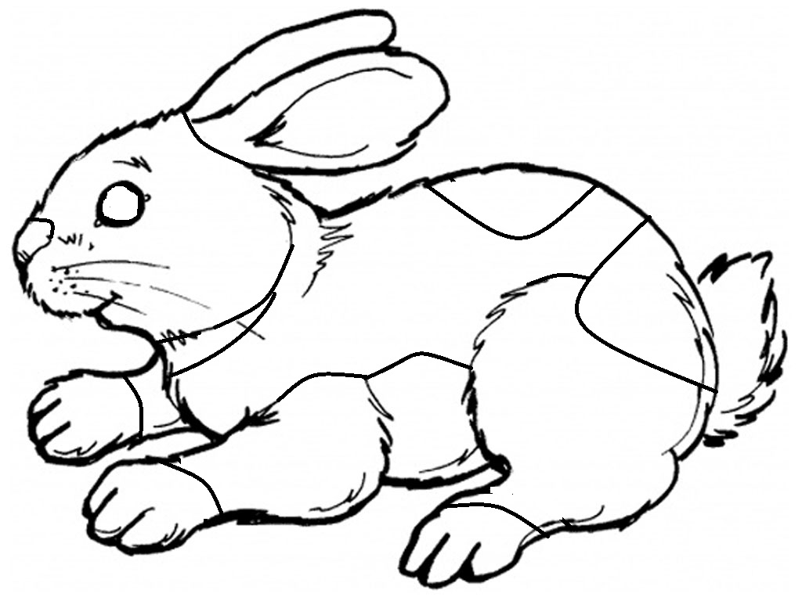**

**COLOR THE PARTS THE FOLLOWING**

**BELLY- PURPLE LOIN- BLUE TAIL- RED**

**EARS- ORANGE NECK- BLUE TOES- ORANGE**

**EYES- GREEN NOSE- YELLOW**

**LEGS- RED RUMP- GREEN**

2023- JR Market Rabbit Notebook Page 9

**TRUE OR FALSE (CIRCLE T for TRUE *or* F for FALSE)**

1. You should begin grooming your rabbits for show at least 6 weeks

before show time? T F

2. Water is the most important nutrient to a rabbit ? T F

3. The most common method of identification is tattooing? T F

4. You should tattoo your rabbit on its stomach? T F

5. You should wean your rabbit at 2-4 weeks old? T F

6. A healthy rabbit should have a wet nose? T F

7. You should carry your rabbit holding the rabbit between your

arm and your body with its eyes covered? T F

8. It’s a good idea to play a radio near your rabbits’ hutch to get

it use to the noise? T F

9. Kits are born very furry with their eyes wide open? T F

10. Different rabbits need different amounts of feed? T F

11. A Buck is a female rabbit? T F

12. Rabbits must be commercial meat type to bring to the

Oceana County Fair for the auction? T F

13. Rabbits must be sold in a pen of 2 for the Fair? T F

14. Each market rabbit must weigh at least 2.5 lbs. to bring to

sell at the Junior Market Auction? T F

2023- JR Market Rabbit Notebook Page 10

**PROJECT INFORMATION**

**What Does Not Belong?**

In each statement one word does not belong, *X (cross)* out that word.

1. Rabbits have**: fur, eyes, beaks, muzzles**

2. Rabbits eat**: grains, water, pellets, pizza**

3. The people who help me take care of and learn about my rabbits are:

**my club leader the veterinarian, my dentist, my parents,**

4. Rabbit breeds: **Holland Lop, Flemish Giant, Muscovy, Mini Rex**

**WHAT DOES YOUR RABBIT NEED?**

(have an adult help you read the following & then **circle those items that your rabbit** needs below)

All living creatures need certain things to survive, like *food*, *water* and shelter. *Farmers* take care of their animals to make sure they are healthy and comfortable. If any rabbits are sick the farmer will treat them with the help of the *veterinarian.* Shelters should have *shade* and not be in the direct sunlight, they sometimes contain *straw* for nesting. Along with *pellets*, small amounts of *hay* may be given to your rabbits. *Corn* is not safe for them to eat.

PUMPKIN CORN WATER CAKE

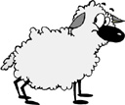

BARN

FARMER

BIKE

JUICE

WATER

CLOTHES

MILK

CORN

VETERINARIAN

TV

CAKE

VETERINARIAN SHADE FARMER PELLETS

 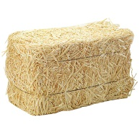 

CANDY STRAW CAGE HAY

2023**-**JR Market Rabbit Notebook Page 11

**Identify Good & Bad Character Actions**

Color in the face, a smiling face is a good action, a frowning face is a bad action. (see the example)

**RAISING and SHOWING an RAISING and SHOWING an**

**ANIMAL *with* CHARACTER ANIMAL *without* CHARACTER**

Feed Animals on Time

Clean cages daily

Complain about the judges

Thank the judge for their time

Insult competitors

Ask for help if you need it

Leave animals outside without shelter

Complete your record book honestly

Have someone else complete your notebook

Congratulate your competitors

****

****

****

****

****

****

****

****

****

****

****

****

****

****

****

****

****

****

How did you show good character this year? Did you help someone, or maybe you treated your animals extra special?

\_\_\_\_\_\_\_\_\_\_\_\_\_\_\_\_\_\_\_\_\_\_\_\_\_\_\_\_\_\_\_\_\_\_\_\_\_\_\_\_\_\_\_\_\_\_\_\_\_\_\_\_\_\_\_\_\_\_\_\_\_\_\_\_\_\_\_\_\_\_\_\_\_\_\_\_\_\_

\_\_\_\_\_\_\_\_\_\_\_\_\_\_\_\_\_\_\_\_\_\_\_\_\_\_\_\_\_\_\_\_\_\_\_\_\_\_\_\_\_\_\_\_\_\_\_\_\_\_\_\_\_\_\_\_\_\_\_\_\_\_\_\_\_\_\_\_\_\_\_\_\_\_\_

\_\_\_\_\_\_\_\_\_\_\_\_\_\_\_\_\_\_\_\_\_\_\_\_\_\_\_\_\_\_\_\_\_\_\_\_\_\_\_\_\_\_\_\_\_\_\_\_\_\_\_\_\_\_\_\_\_\_\_\_\_\_\_\_\_\_\_\_\_\_\_\_\_\_\_\_

2023-JR Market Rabbit Notebook Page 12

**4-H KNOWLEDGE**

**The 4-H Pledge**- *Draw a line to the picture that fills in the blank* (see the example)

***I pledge…***





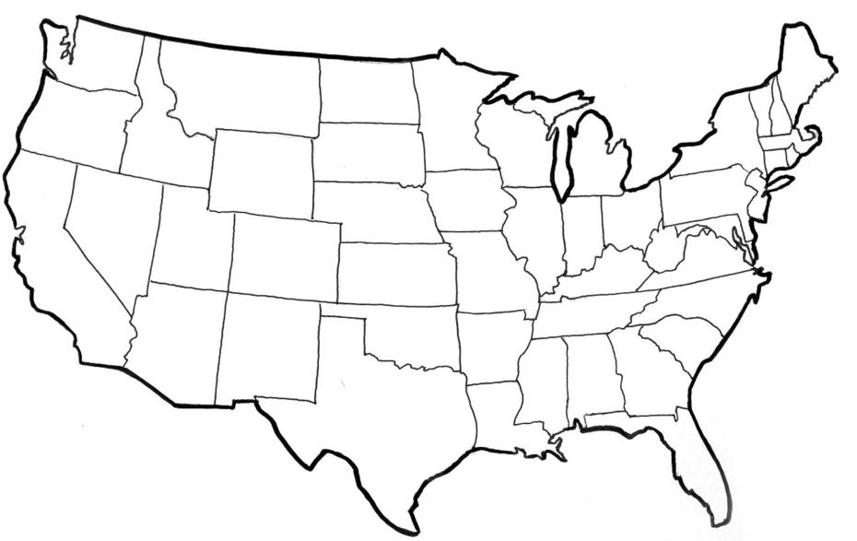

HANDS

HEALTH

HEAD

HEART

WORLD

COUNTRY

CLUB

COMMUNITY

My \_\_\_\_\_\_\_\_\_\_\_\_ to clearer thinking,

My \_\_\_\_\_\_\_\_\_\_\_\_ to greater loyalty,

My \_\_\_\_\_\_\_\_\_\_\_\_ to larger service, and

My \_\_\_\_\_\_\_\_\_\_\_\_\_ to better living,

for my \_\_\_\_\_\_\_\_\_\_\_\_\_\_\_\_\_\_\_\_,

my \_\_\_\_\_\_\_\_\_\_\_\_\_\_\_\_\_\_\_\_\_\_\_,

my \_\_\_\_\_\_\_\_\_\_\_\_\_\_\_\_\_\_\_\_\_\_\_,

and my \_\_\_\_\_\_\_\_\_\_\_\_\_\_\_\_\_\_\_\_.

Number of club meetings held: **\_\_\_\_\_\_\_\_\_** Number I attended: **\_\_\_\_\_\_\_\_**

2023-JUNIOR MARKET RABBITS PAGE 13

**MY STORY**

(Interesting things that happened to me and my animal this year, challenges, highlights of my year or ***ANYTHING*** I would like to share about my overall

experience. You can even draw a picture of you and your animals if you prefer).

**The judge may ask you about the parts of your rabbit during showmanship. Write the correct number from the part above**

**in front of the correct part below**

\_\_\_\_\_Toes \_\_\_\_\_Nose \_\_\_\_\_Hock \_\_\_\_\_Ear

\_\_\_\_\_Tail \_\_\_\_\_Neck \_\_\_\_\_Hip \_\_\_\_\_Dewlap

\_\_\_\_\_Shoulder \_\_\_\_\_Mouth \_\_\_\_\_Foot \_\_\_\_\_Chest

\_\_\_\_\_Rump \_\_\_\_\_Loin \_\_\_\_\_Flank \_\_\_\_\_Cheek

\_\_\_\_\_Rib \_\_\_\_\_Leg \_\_\_\_\_\_Eye \_\_\_\_\_Belly

***POTENTIAL BUYERS NAMES***

As part of your 4-H Small Market Livestock Project, you must personally contact at least three potential buyers before the Oceana County Fair. You are encouraged to seek two new buyers that have not been asked or submitted before. **You also must have at least three different buyers than those of your siblings in the market livestock project.** Please confirm with your buyers their accurate mailing address (example: post office box vs. a street address). The information on page 14 must be completed and taken to the Oceana County MSU Extension Office on or before the due date where it will be **copied** and used to send out letters to your potential buyers. This page will remain in your notebooks. This is a Market Livestock Committee rule. Failure to comply will result in not being able to sell your animal in the 4-H Market Livestock Sale.

2023-JR MARKET RABBITS Stamp \_\_\_\_\_\_\_\_\_\_\_\_\_\_\_

PAGE 14 Staff \_\_\_\_\_

\_\_\_\_\_\_\_\_\_\_

**JUNIOR MARKET/SMALL MARKET POTENTIAL BUYER’S LIST**

**RABBIT PROJECT (AGES 5-7)**

Name\_\_\_\_\_\_\_\_\_\_\_\_\_\_\_\_\_\_\_\_\_\_\_\_\_\_\_\_\_\_ Club\_\_\_\_\_\_\_\_\_\_\_\_\_\_\_\_\_\_\_\_\_\_\_\_\_

***Please print business names and complete addresses clearly.***

* 1. Contact Name \_\_\_\_\_\_\_\_\_\_\_\_\_\_\_\_\_\_\_\_\_\_\_\_\_\_\_\_\_\_\_\_\_\_\_\_\_\_\_\_\_\_\_\_\_\_\_\_­­\_\_\_\_

Business Name \_\_\_\_\_\_\_\_\_\_\_\_\_\_\_\_\_\_\_\_\_\_\_\_\_\_\_\_\_\_\_\_\_\_\_\_\_\_\_\_\_\_\_\_\_\_\_\_\_\_\_\_

**Mailing** Address \_\_\_\_\_\_\_\_\_\_\_\_\_\_\_\_\_\_\_\_\_\_\_\_\_City\_\_­­­­­­­­\_\_­­­­­­­\_\_\_\_\_\_\_\_\_\_\_\_\_Zip\_\_\_\_\_

Phone \_\_\_\_\_\_\_\_\_\_\_\_\_\_\_\_\_\_\_\_\_\_\_ After Hours Phone\_\_\_\_\_\_\_\_\_\_\_\_\_\_\_\_\_\_\_\_\_\_

Mailing Preference (Please Check One): Email \_\_\_\_ Postal Delivery \_\_\_\_

Email \_\_\_\_\_\_\_\_\_\_\_\_\_\_\_\_\_\_\_\_\_\_\_\_\_\_\_\_\_\_\_\_\_\_\_\_\_\_\_\_\_\_\_\_\_\_\_\_\_\_\_\_\_\_\_\_\_\_\_\_

Signature\_\_\_\_\_\_\_\_\_\_\_\_\_\_\_\_\_\_\_\_\_\_\_\_\_\_\_\_\_\_\_\_\_\_\_\_\_\_\_\_\_\_\_\_\_\_\_\_\_\_\_\_\_\_\_\_\_\_

2. Contact Name \_\_\_\_\_\_\_\_\_\_\_\_\_\_\_\_\_\_\_\_\_\_\_\_\_\_\_\_\_\_\_\_\_\_\_\_\_\_\_\_\_\_\_\_\_\_\_\_­­\_\_\_\_

Business Name \_\_\_\_\_\_\_\_\_\_\_\_\_\_\_\_\_\_\_\_\_\_\_\_\_\_\_\_\_\_\_\_\_\_\_\_\_\_\_\_\_\_\_\_\_\_\_\_\_\_\_\_

**Mailing** Address \_\_\_\_\_\_\_\_\_\_\_\_\_\_\_\_\_\_\_\_\_\_\_\_\_City\_\_­­­­­­­­\_\_­­­­­­­\_\_\_\_\_\_\_\_\_\_\_\_\_Zip\_\_\_\_\_

Phone \_\_\_\_\_\_\_\_\_\_\_\_\_\_\_\_\_\_\_\_\_\_\_ After Hours Phone\_\_\_\_\_\_\_\_\_\_\_\_\_\_\_\_\_\_\_\_\_\_

Mailing Preference (Please Check One): Email \_\_\_\_ Postal Delivery \_\_\_\_

Email \_\_\_\_\_\_\_\_\_\_\_\_\_\_\_\_\_\_\_\_\_\_\_\_\_\_\_\_\_\_\_\_\_\_\_\_\_\_\_\_\_\_\_\_\_\_\_\_\_\_\_\_\_\_\_\_\_\_\_\_

Signature\_\_\_\_\_\_\_\_\_\_\_\_\_\_\_\_\_\_\_\_\_\_\_\_\_\_\_\_\_\_\_\_\_\_\_\_\_\_\_\_\_\_\_\_\_\_\_\_\_\_\_\_\_\_\_\_\_\_

3. Contact Name \_\_\_\_\_\_\_\_\_\_\_\_\_\_\_\_\_\_\_\_\_\_\_\_\_\_\_\_\_\_\_\_\_\_\_\_\_\_\_\_\_\_\_\_\_\_\_\_­­\_\_\_\_

Business Name \_\_\_\_\_\_\_\_\_\_\_\_\_\_\_\_\_\_\_\_\_\_\_\_\_\_\_\_\_\_\_\_\_\_\_\_\_\_\_\_\_\_\_\_\_\_\_\_\_\_\_\_

**Mailing** Address \_\_\_\_\_\_\_\_\_\_\_\_\_\_\_\_\_\_\_\_\_\_\_\_\_City\_\_­­­­­­­­\_\_­­­­­­­\_\_\_\_\_\_\_\_\_\_\_\_\_Zip\_\_\_\_\_

Phone \_\_\_\_\_\_\_\_\_\_\_\_\_\_\_\_\_\_\_\_\_\_\_ After Hours Phone\_\_\_\_\_\_\_\_\_\_\_\_\_\_\_\_\_\_\_\_\_\_

Mailing Preference (Please Check One): Email \_\_\_\_ Postal Delivery \_\_\_\_

Email \_\_\_\_\_\_\_\_\_\_\_\_\_\_\_\_\_\_\_\_\_\_\_\_\_\_\_\_\_\_\_\_\_\_\_\_\_\_\_\_\_\_\_\_\_\_\_\_\_\_\_\_\_\_\_\_\_\_\_\_

Signature\_\_\_\_\_\_\_\_\_\_\_\_\_\_\_\_\_\_\_\_\_\_\_\_\_\_\_\_\_\_\_\_\_\_\_\_\_\_\_\_\_\_\_\_\_\_\_\_\_\_\_\_\_\_\_\_\_\_

(Must be stamped by the MSU Extension Office)

2023- JR Market Rabbit Notebook Page 15

**PICTURES OF YOUR PROJECT**

(Please use this page for your project pictures. Add additional pages if you would like. The judges appreciate you labeling the pictures so they know what the picture shows.)

***NON-CLUB* POINTS- JUNIOR/SMALL MARKET PROJECT**

***(This must be filled out by participant before presenting for signatures at the MSUE office)***

|  |  |  |  |  |
| --- | --- | --- | --- | --- |
| **MEETING NAME** | **LOCATION** | **DATE** | **POINTS** | **SIGNATURE OF LEADER, SUPERINTENDENT OR MSU STAFF** |
|  |  |  |  |  |
|  |  |  |  |  |
|  |  |  |  |  |
|  |  |  |  |  |
|  |  |  |  |  |
|  |  |  |  |  |
|  |  |  |  |  |
|  |  |  |  |  |
|  |  |  |  |  |
|  |  |  |  |  |

Please note: This form must be included with your record notebook and turned into the weigh master on entry day of the Fair. **BEFORE SEEKING SIGNATURES AT MSU EXTENSION – MEETING NAME AND DATE MUST BE COMPLETED** You need to accumulate **nine (9) points** to be allowed to sell your animal. **Six (6)** of these **nine (9) points** must come from club meetings. The **three (3)** non-club points must be earned from attending various 4-H events and activities. See your leader, the MSUE office, or online at <https://www.canr.msu.edu/oceana/oceana_county_4_h/oceana_4_h_market_livestock> for a listing of approved nonclub points.

**JUNIOR/SMALL MARKET PROJECT CLUB POINTS**

***(This must be filled out by participant before presenting for signatures at the MSUE office)***

|  |  |  |  |  |
| --- | --- | --- | --- | --- |
| **MEETING NAME** | **LOCATION** | **DATE** | **POINTS** | **SIGNATURE OF LEADER, SUPERINTENDENT OR MSU STAFF** |
|  |  |  |  |  |
|  |  |  |  |  |
|  |  |  |  |  |
|  |  |  |  |  |
|  |  |  |  |  |
|  |  |  |  |  |
|  |  |  |  |  |
|  |  |  |  |  |
|  |  |  |  |  |
|  |  |  |  |  |
|  |  |  |  |  |

Please note: This form must be included with your record notebook and turned into the weigh master on entry day of the Fair. You need to accumulate **nine (9) points** to be allowed to sell your animal. **Six (6)** of these **nine (9) points** must come from club meetings. The **three (3)** non-club points must be earned from attending various 4-H events and activities